Activity No.07
Aim: How to Share Printer on Network (Share Printer in-between Computers).
Theory:
In Windows 10, you can share your printer with many PCs on your network. To share a printer from the PC that the printer is connected to (the primary PC) with secondary PCs that the printer is not connected to, you must set up sharing settings for the printer, connect the printer to the primary PC (either wirelessly or by using a USB cable), and then turn on the printer. Also make sure the primary PC is turned on, connected to the printer, and connected to the network.
Procedures:
Set Up Sharing Setting :
- Select the Start button, then select Settings > Network & Internet > Wi-Fi.
- Under Related settings, select Change advanced sharing options.
- In the Advanced sharing settings dialog box, expand the Private section. Next, under Network discovery, select Turn on network discovery.
- Under File and printer sharing, select Turn on file and printer sharing.
Share your printer using Settings :
- Select the Start button, then select Settings > Devices > Printers & scanners.
- Choose the printer you want to share, then select Manage.
- Select Printer Properties, then choose the Sharing tab.
- On the Sharing tab, select Share this printer.
- If you want, edit the Share name of the printer. You'll use this name to connect to the printer from a secondary PC. When you are done, select OK.
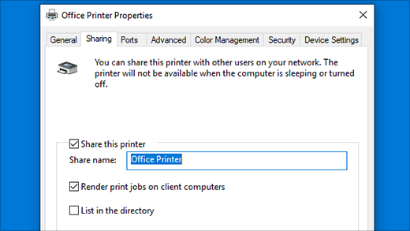

Share your printer using Control Panel :
- In the search box on the taskbar, type control panel and then select Control Panel.
- Under Hardware and Sound, select View devices and printers, or select Devices and Printers.
- Select and hold (or right-click) the printer you want to share, select Printer properties, and then choose the Sharing tab.
- On the Sharing tab, select Share this printer.
- If you want, edit the share name of the printer. You'll use this name to connect to the printer from a secondary PC. When you are done, select OK.
- 

